CDAC NOIDA SEPT_2022_B_BATCH

SANDEEP K. GADHE

LAB ASSIGNMENT 1: CONCEPT OF PROGRAMING.

**Q 1 Write a program to find sum of all integers greater than 100 and less than 200 that are divisible by 7.**

**Ans.** 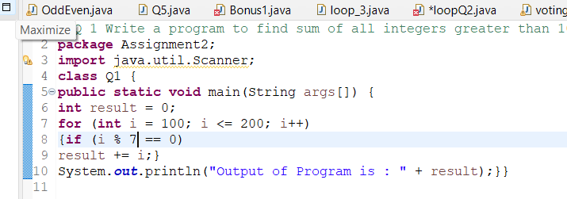

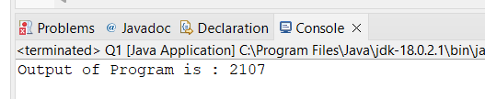

**2 Write a program in java that ask three numbers from  
user and print the greatest among three .**

**Ans.**

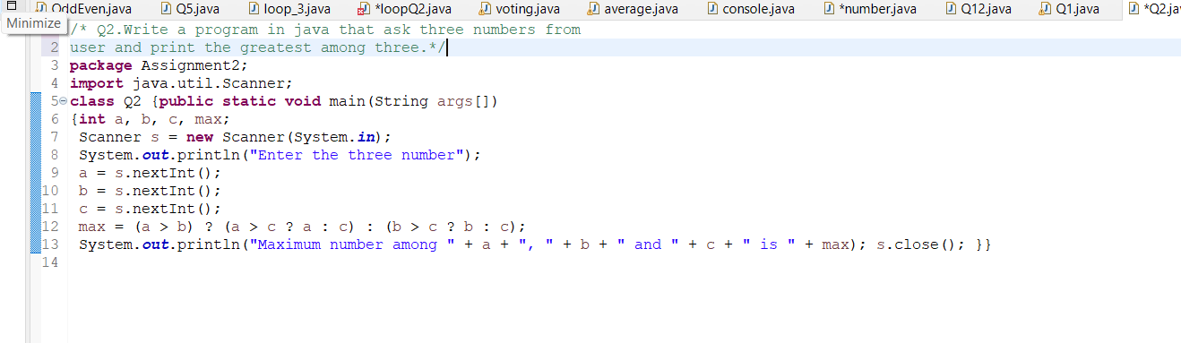

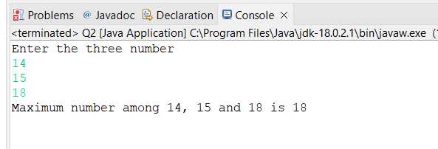

**3. WAP to find  ASCII value of a character** .

**Ans**

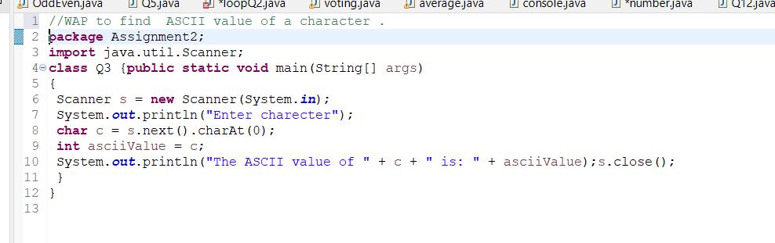

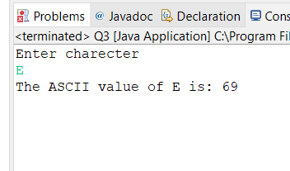

**4. Java Program to Check Whether an Alphabet is Vowel or Consonant.**

**Ans.** 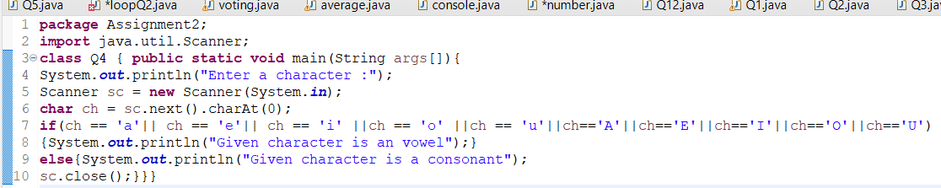

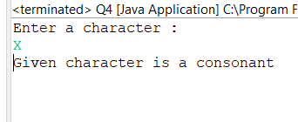

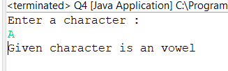

5 Check if a Number is Positive or Negative using if else.

Ans

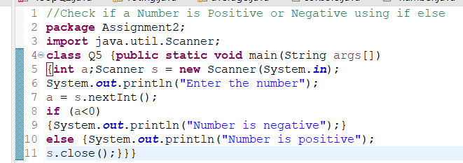

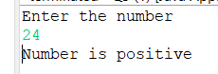

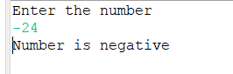

**6 WAP for swapping two numbers without using third variable.**

**Ans.**

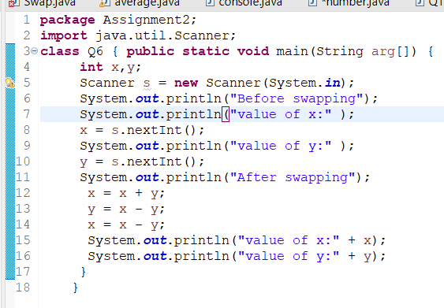

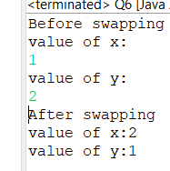

**7 Write a program that would print the information (name,  
year of joining, salary, address) of three employees by creating a class named  
'Employee'. The output should be as follows:  
Name           Year of joining        Address  
Ashish          1994                       64C- WallsStreat  
Sam           2000                      68D- WallsStreat                     
John   1999                     26B- WallsStreat**

**Ans**

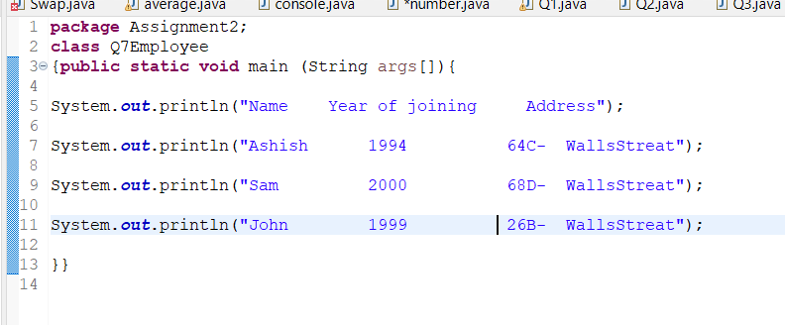

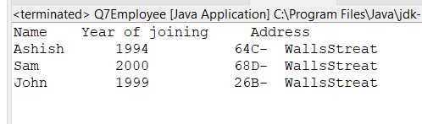

**Q  8 Q  wap to print even numbers between 10 to 20.**

**Ans.**

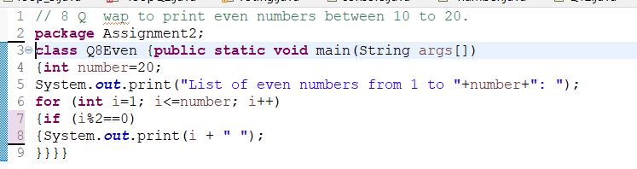



**Q9.wap to check if a number is prime or not.**

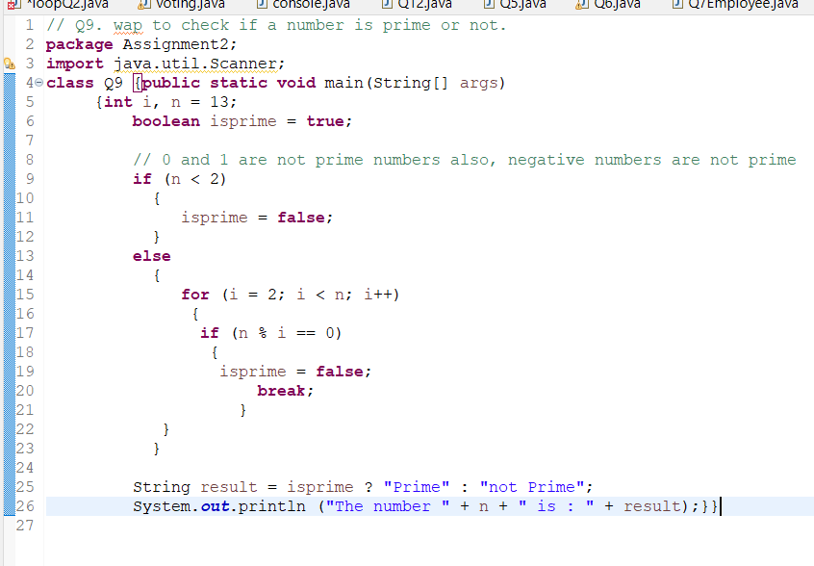

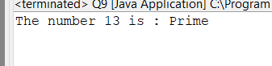

Q 10 wap to reverse a given digit   123   321

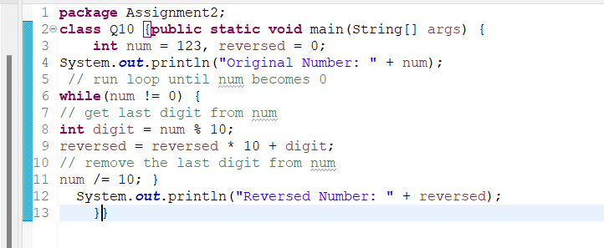

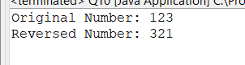

**Thank you!**